**Name:** Megan Jacobs **Date:** 11/02/2021

**Lab section:** Tuesday

**Show your work!!!**

# Acquire

Week: 32

Date: August 10th Year: 2020Data: Benefits of Remote Working

**Source Article/Visualization:**

<https://www.visualcapitalist.com/how-people-and-companies-feel-about-working-remotely/>

<https://lp.buffer.com/state-of-remote-work-2020> (where the data originally comes from)

<https://www.makeovermonday.co.uk/data/data-sets-2018/>

# Represent

# 

# Critique

Critique the visualization:

I really enjoy the use of color within the visualization. It is easy to distinguish between the benefits to remote working. I also enjoy the use of big fonts on the visualization makes it easy to see what each category is.

What I dislike about this visualization is the graphic that is used and all the other extra text around it. It distracts the audience away from the visualization instead of just having it their to focus on the insights and data to it.

After reading about the Periodic Table of Visualization Methods, I would say that this chart is a Convergent thinking and overview visualization. This is because the graphic gives us a total of all the data that is categorized, and it is convergent in nature because it reduces the complexity of the data we are looking at. Finally, I would say that this visualization falls under the data visualization category because it is representing quantitative data in a format that is schematic.

# Mine

What different benefits besides the ones listed are there?

Are there any drawbacks to working at home?

What makes up the other 3% of benefits?

**Filter**

This is the file that came from makeover Monday. But after doing some research I found the site that it was originally taken from so here is that data.

# Stakeholders

1. Audience: Employees working from home, companies thinking of switching to more remote based work, managers or supervisors debating remote working compared to in person work.
2. Assumptions: Tested in 2020 (actually started gathering data in 2019). All participants were from the United States
3. Tool: Tableau

**What to submit:** This document in PDF format only (if you do not know how to do this, ask).

**Choose the best layout** for your makeover visualization: Portrait or Landscape, Remove the page of the layout that you DO NOT choose. No blank pages!

# NEW Sketch your Makeover

In the space below, sketch out your ideas for refined visualization. You must use pen/pencil and paper to sketch out your idea, then take a photo of your sketch and include it in the space below.

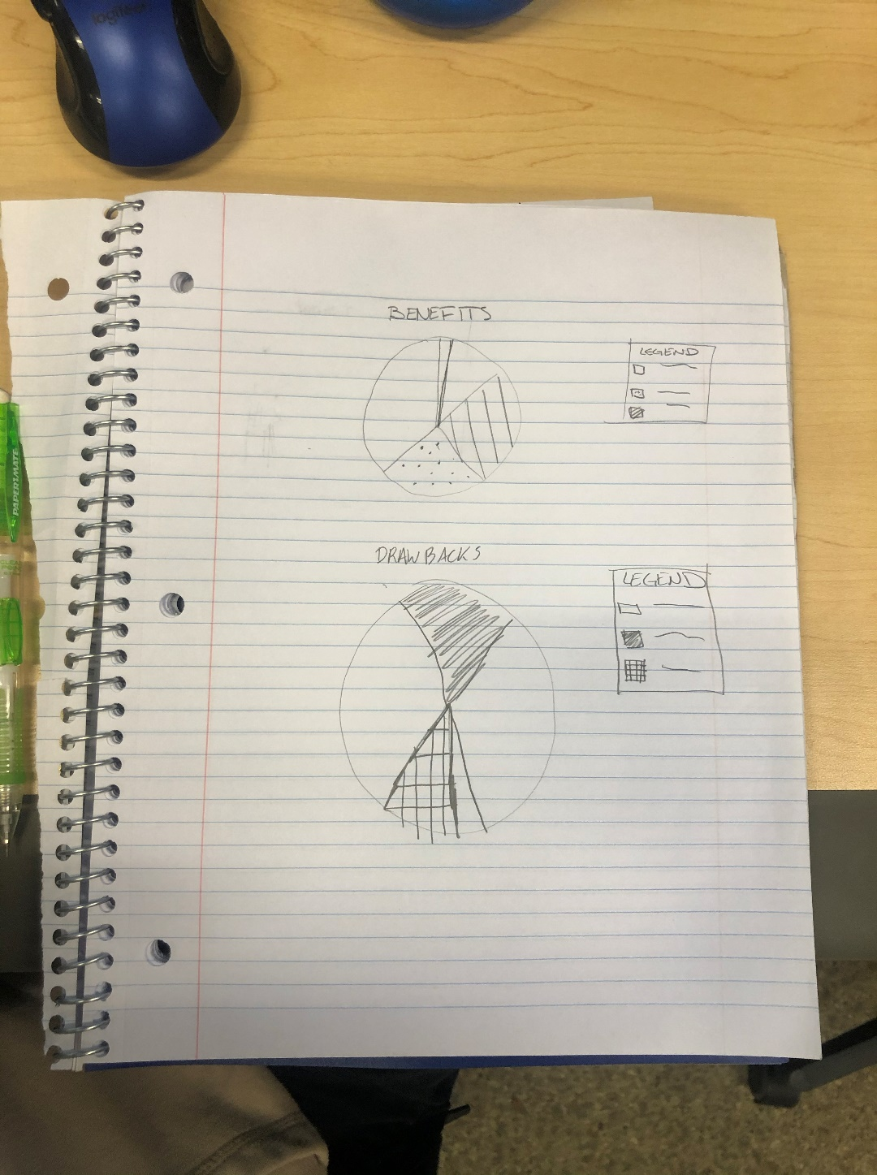

# Refine (Makeover – Portrait View)

In the space below, show the computer-generated version of your sketch using the visualization tool of your choice. DO NOT draw what you sketched. The visualization should be created with the visualization tool (Tableau, Excel, Power BI, etc., of your choosing). Remember, the purpose of visualization is *“insight.”* Take and include a screenshot of your visualization and include it below. Use Data Visualization Best Practices (see data visualization checklist).

Figure 1. The redesign of the visualization found in the beginning of the document. This visualization also includes the drawbacks to remote working so that the audience can compare and weight the options on whether working remotely is a good thing or not.

CGT 270 Data Visualization

Makeover Monday #3 (2020 Dataset)

# Resources

Data Visualization Checklist: <http://stephanieevergreen.com/wp-content/uploads/2016/10/DataVizChecklist_May2016.pdf>

How to give constructive criticism: <https://personalexcellence.co/blog/constructive-criticism/>

Sample Makeovers <https://www.makeovermonday.co.uk/gallery/>

# Grading Rubric

|  |  |  |  |
| --- | --- | --- | --- |
| **Excellent (11-15 pts)** | **Good**  **(6 -10 pts)** | **Fair**  **(2-5 pts)** | **Needs Improvement**  **(0 - 1 pt)** |
| Meets **ALL** or most of these: Makeover is esthetically pleasing (color, perception), best practices followed (insightful), Correct dataset downloaded; provided an interesting point of view of the data; critiqued previous makeover, critique is constructive (indicates one thing that is done well, and one thing that could be done differently, what will be done to improve the visualization), assumptions (more than one) are listed. | Meets **MOST** of these: Makeover is esthetically pleasing (color, perception), best practices followed (insightful), Correct dataset downloaded; provided an interesting point of view of the data; critiqued previous makeover, critique is constructive (indicates one thing that is done well, and one thing that could be done differently, what will be done to improve the  visualization), assumptions (more than one) are listed. | Consistently meets **SOME** of these: Makeover is esthetically pleasing (color, perception), best practices followed (insightful), Correct dataset downloaded; provided an interesting point of view of the data; critiqued previous makeover, critique is constructive  (Indicates one thing that is done well, and one thing that could be done differently, what will be done to improve the  visualization), assumptions (more than one) are listed. | Little to no evidence of the understanding of the data visualization process.  Lackluster makeover or no makeover.  Little effort. |
| Sketch included: hand drawn [5 pts] | Sketch included, but was generated by computer [2 pts] | No sketch included. [0 pts] |  |
| Makeover Monday  Assessment Completed  [5 pts] | Makeover Monday Assessment not completed [0 pts] |  |  |

Fall 2021 – Makeover Monday #3